EXPERIMENT 1: 8 PUZZLE PROBLEM
Aim
To develop a Python program to solve the 8-Puzzle problem using an AI search technique.
Objective
- To understand state-space search.
- To find the shortest path from the initial state to the goal state.
Algorithm
- Start.
- Read the initial puzzle state.
- Compare it with the goal state.
- If the goal is reached, display the solution.
- Otherwise, generate all possible moves of the blank tile.
- Select the next valid state.
- Repeat Steps 3–6 until the goal state is reached.
- Stop.
Flowchart
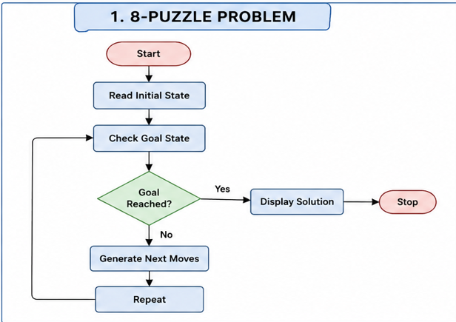

OUTPUT SCREENSHOT

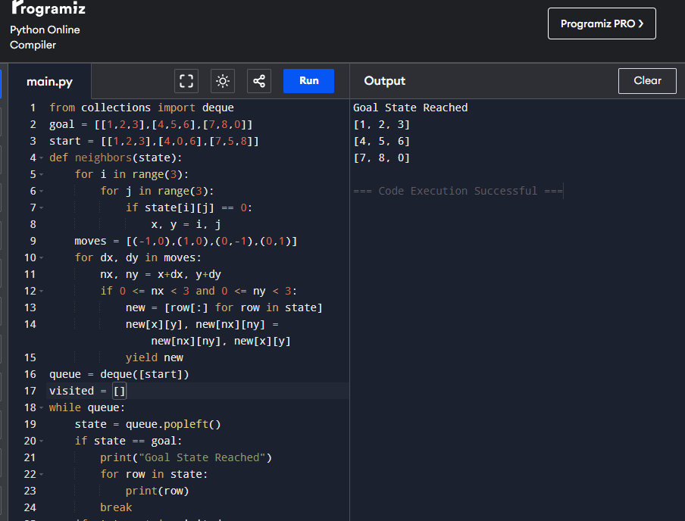

Result
Thus, the 8-Puzzle problem was solved successfully, and the goal state was reached.
Conclusion
Thus, the 8-Puzzle problem was solved successfully by reaching the goal state using a search technique.

Experiment 2: 8-Queen Problem
Aim
To write a Python program to solve the 8-Queen problem using the Backtracking algorithm.
Objective
- To place eight queens on a chessboard.
- To ensure that no two queens attack each other.
Algorithm
- Start.
- Place a queen in the current column.
- Check whether the position is safe.
- If safe, place the queen and move to the next column.
- If not safe, try the next row.
- Repeat until all queens are placed.
- Display the solution.
- Stop.
Flowchart
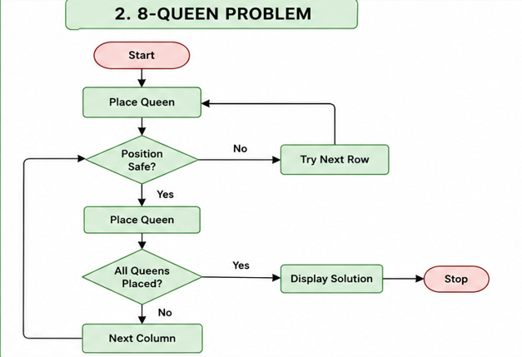

OUTPUT SCREENSHOT
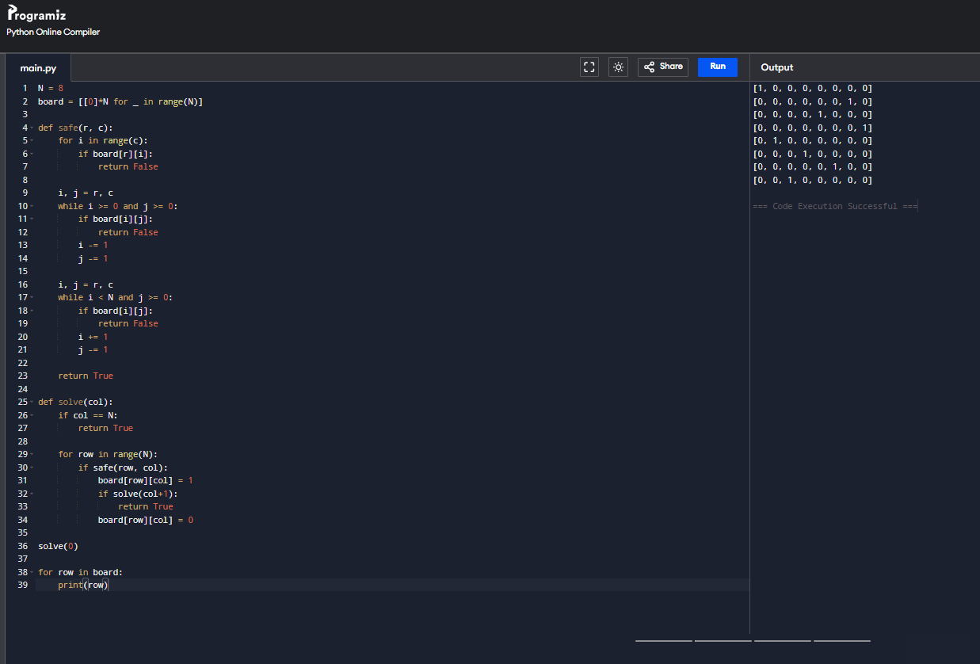

Result
Thus, the 8-Queen problem was solved successfully by placing all eight queens without attacking each other.
Conclusion
Thus, the Backtracking algorithm successfully solved the 8-Queen problem.

Experiment 3: Water Jug Problem
Aim
To write a Python program to solve the Water Jug problem.
Objective
- To obtain the required quantity of water.
- To understand state-space search.
Algorithm
- Start.
- Initialize both jugs.
- Perform fill, empty, or pour operations.
- Check whether the target amount is reached.
- If yes, display the result.
- Otherwise, repeat the operations.
- Stop.
Flowchart
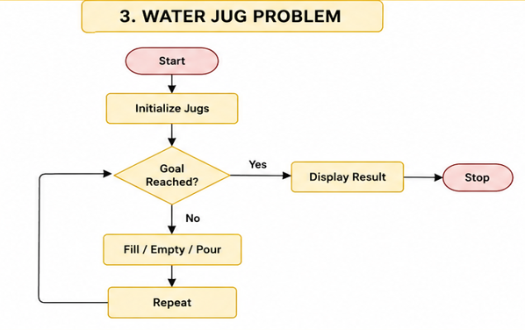

OUTPUT SCREENSHOT
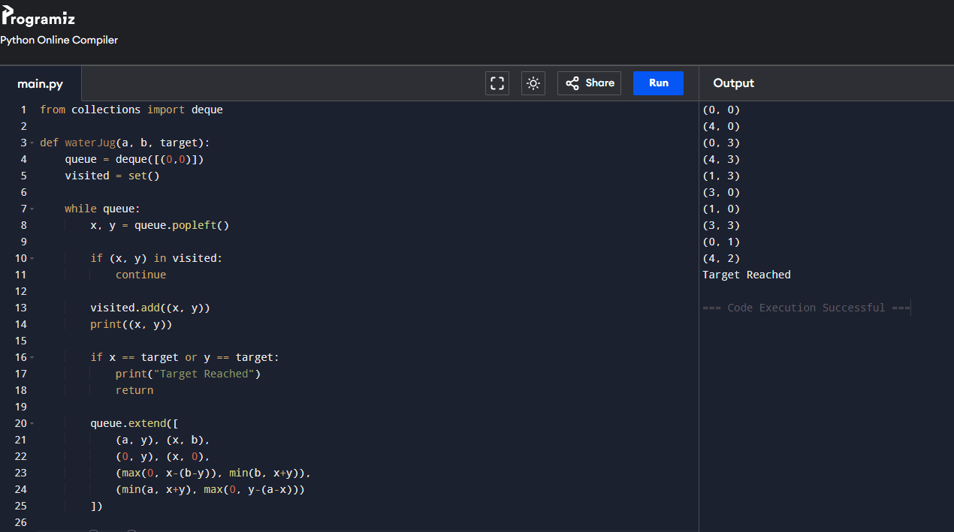

Result
Thus, the required quantity of water was obtained successfully.
Conclusion
Thus, the Water Jug problem was solved successfully using state-space search.

Experiment 4: Crypt-Arithmetic Problem
Aim
To write a Python program to solve the Crypt-Arithmetic problem.
Objective
- To assign unique digits to letters.
- To satisfy the given arithmetic equation.
Algorithm
- Start.
- Read the puzzle.
- Assign digits to the letters.
- Check whether the equation is satisfied.
- If yes, display the solution.
- Otherwise, try another assignment.
- Stop.
Flowchart
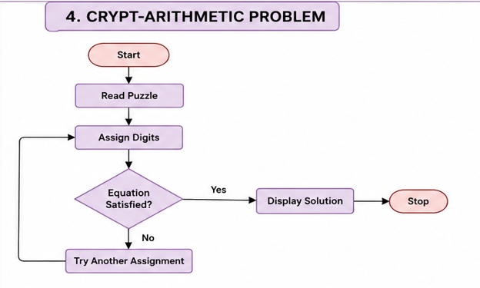

OUTPUT SCREENSHOT
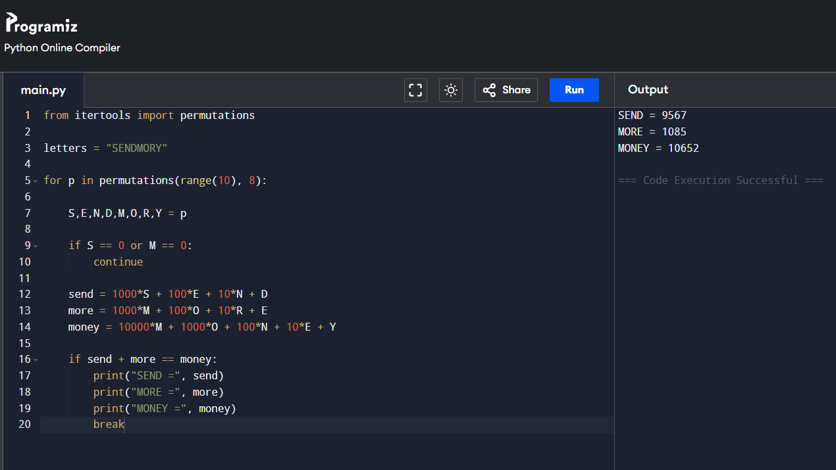

Result
Thus, the Crypt-Arithmetic problem was solved successfully by assigning unique digits to the letters.
Conclusion
Thus, the Crypt-Arithmetic problem was solved successfully, satisfying the equation SEND + MORE = MONEY.

